National Cheng Kung University
Department of Electrical Engineering

Introduction to VLSI CAD (Spring 2018)

Lab Session 7

Simple Image Processing Unit

PS: Two people per group, only one person has to upload the project.
Name | Student ID
Practical Sections: |  | Points | Marks
Part1 |  | 25
Part2 |  | 25
Part3 |  | 25
Synthesized Unit(No need Word Files) |  | 25
Bonus |  | 100
Notes

Due date: 05 , 09 , 2018 @ moodle
Deliverables
- All Verilog codes including testbenches for each problem should be uploaded.
NOTE: Please DO NOT include source code in the paper report!
- Important! TA will use the command in Appendix A to check your design under SoC Lab environment, if your code can not be recompiled by TA successfully using the commands, you will not get full credit.
- If you upload a dead body which we can’t even compile you will get NO credit!
- All homework requirements should be uploaded in this file hierarchy or you will not get full credit.

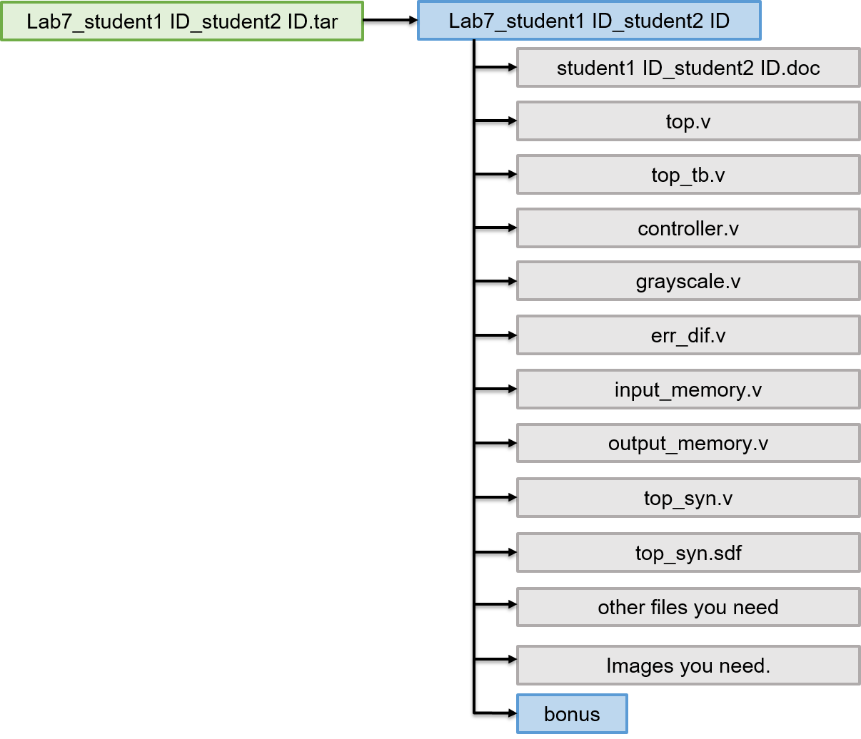
Part1
- Please follow the image processing steps (including both grayscale and error diffusion)and calculate 4 red pixels in the 4x4 image bellow. You need to show us the calculation process or you will get no credit. When you do grayscale or error diffusion, please chop off the fractional numbers to let the pixel become an integer result.(無條件捨去小數位)


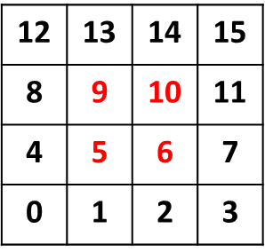

 | Input memory
mem[15] | 24 1c ed
mem[14] | 1d e6 b5
mem[13] | e7 bf c8
mem[12] | 27 7f ff
mem[11] | b0 e4 ef
mem[10] | a4 49 a3
mem[9] | e8 a2 20
mem[8] | 4c b1 22
mem[7] | e8 a2 20
mem[6] | be 92 70
mem[5] | 57 7a b9
mem[4] | c3 c3 c3
mem[3] | 15 20 88
mem[2] | 7f 7f 7f
mem[1] | ea d9 99
mem[0] | c9 ae ff

Part2
- Complete the whole system and show your final results of
snoopy.bmp、NCKU.bmp and pikachu.bmp .

Original Image | Results

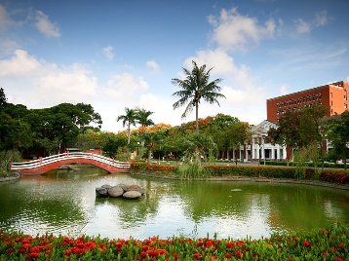


Part3
- Show your final results of three other images you choose

Original Image | Results

Bonus
- (50%) Show us how you deal with boundary cases in detail. You will get more points if you implements more methods.
- (50%) Change the size of the image to 1280x720. You should put all bonus files in the bonus folder.
Appendix A: Commands we will use to check your homework
RTL:
ncverilog top_tb.v +define+FSDB +access+r
Synthesis:
ncverilog top_syn_tb.v +define+FSDB +access+r
Appendix B: Port List
- top
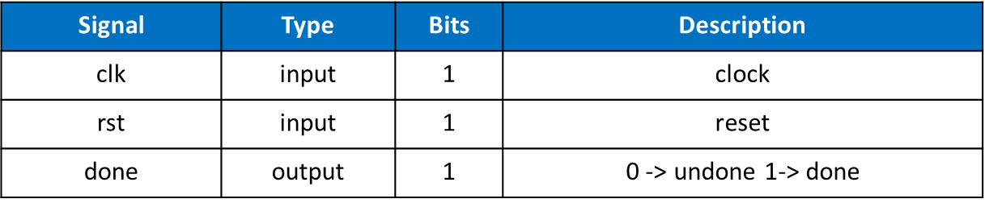

- controller
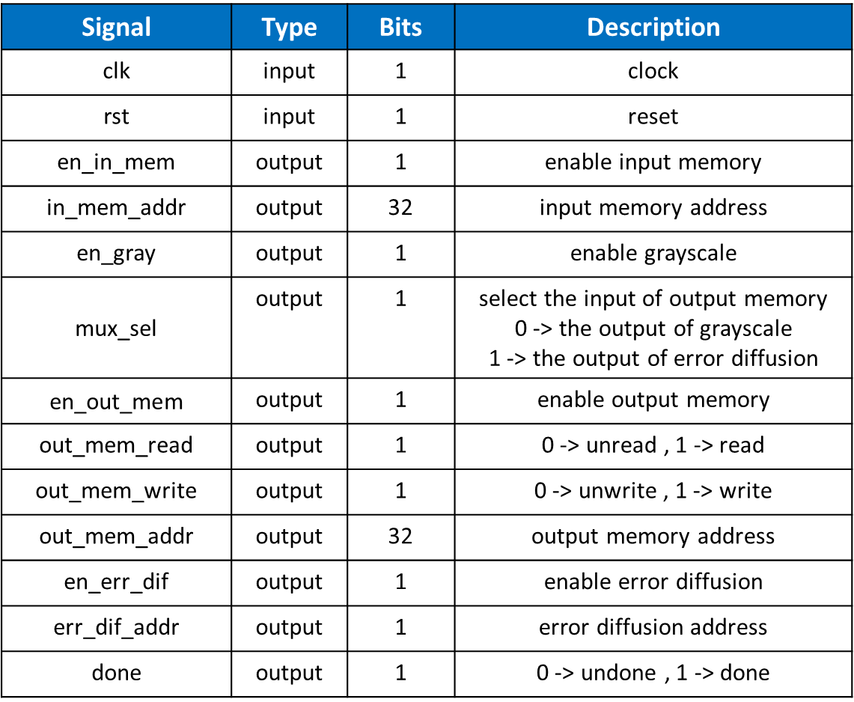

- input_memory
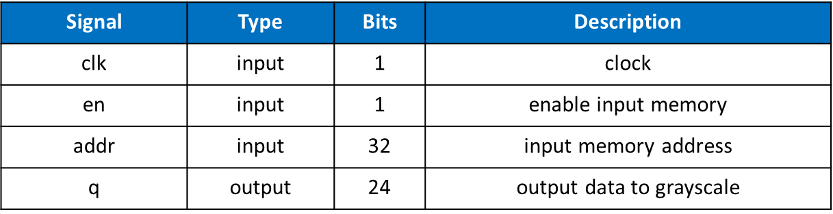

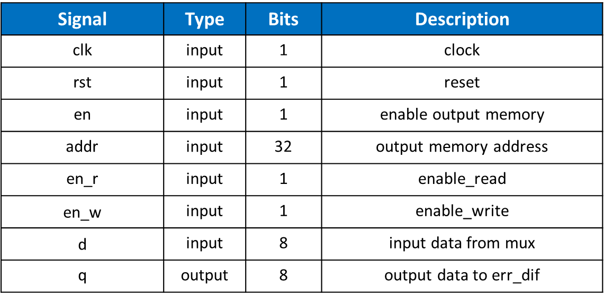
- output_memory
- grayscale
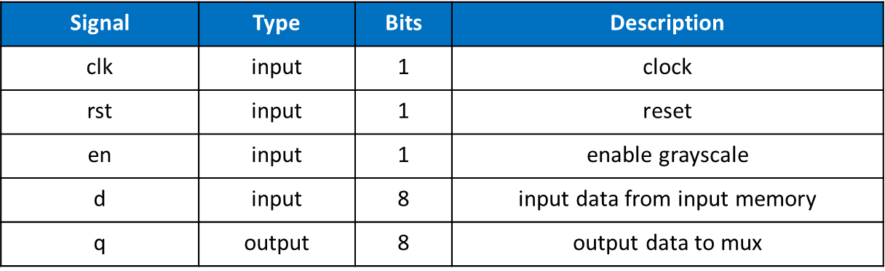
- err_dif
